Air Quality Monitoring System Using SPS30, DHT11 and ESP32

Abstract
This project presents an IoT-based air quality monitoring system that leverages the Sensirion SPS30 sensor integrated with the ESP32 microcontroller. The SPS30 measures particulate matter (PM1.0, PM2.5, PM4.0, and PM10), Number of Concentration of particle (NC0.5, NC1.0, NC2.5, NC4.0, NC10) along with Typical particle size in the surrounding air while the DHT11 monitors temperature and humidity. The ESP32, equipped with Wi-Fi capabilities, transmits the sensor data to an MQTT broker, which is then forwarded to the VYOM platform for real-time monitoring and analysis. The system is designed for precision, reliability, and scalability, making it suitable for smart city applications and environmental monitoring.
Chapter 1
Introduction

Air pollution is one of the most critical environmental challenges of modern times, affecting human health and ecological balance. The need for real-time, accurate air quality data is increasing rapidly for applications such as public health monitoring, urban planning, and industrial emissions control. This project introduces a compact and efficient IoT-based Air Quality Monitoring System using the SPS30 sensor and ESP32 microcontroller. It captures and transmits particulate matter levels (PM1.0, PM2.5, PM4.0, PM10), Number of Concentration of particle (NC0.5, NC1.0, NC2.5, NC4.0, NC10) along with Typical particle size, temperature, and humidity to the cloud for real-time visualization using the VYOM Platform.

1.1 Objective
- To monitor environmental parameters like PM1.0, PM2.5, PM4.0, PM10, NC0.5, NC1.0, NC2.5, NC4.0, NC10 and Typical particle size.
- To monitor temperature and humidity using the DHT11 sensor.
- To transmit data using MQTT protocol from ESP32 to the VYOM Platform dashboard.
- To visualize and analyze real-time data for air quality assessment.
Chapter 2
Component Selection and Justification

2.1 COMPONENTS USED
- ESP32 Microcontroller
A low-cost, low-power system-on-chip microcontroller with integrated Wi-Fi and dual-mode Bluetooth.
- SPS30 Sensor (Sensirion)
A high-precision laser-based sensor capable of measuring PM1.0, PM2.5, PM4.0, PM10, Number of Concentration of particle (NC0.5, NC1.0, NC2.5, NC4.0, NC10) and Typical particle size.
- DHT11 Sensor
A basic, low-cost digital sensor for measuring temperature and humidity, ideal for environmental monitoring applications.
- Breadboard and Jumper Wires
For non-permanent circuit setup and component connection.
- 5V USB Power Supply
For powering the ESP32 and sensor.
- MQTT Broker (Public or Local)
For efficient message transmission from device to dashboard.
- VYOM Platform Cloud Platform
For visualization and monitoring of environmental data.

2.2 WHY SPS30 AND ESP32?
- SPS30 Advantages
  - Based on laser scattering technology for higher accuracy.
  - Can detect a broad range of particulate matter sizes.
  - Long-lasting performance with minimal maintenance.
- ESP32 Advantages
  - Inbuilt Wi-Fi and Bluetooth for wireless communication.
  - Excellent community support and compatible with Arduino IDE.
  - Dual-core processor for faster processing.

Chapter 3
System Design

3.1 Architecture

System Architecture Overview

1. Sensor Layer (Data Acquisition)
- SPS30 Sensor continuously monitors:
  - PM1.0, PM2.5, PM4.0, PM10 (Particulate Matter)
  - NC0.5, NC1.0, NC2.5, NC4.0, NC10 (Number of Concentration of particle)
  - Typical particle size.
• DHT11 Sensor monitors: Ambient temperature and humidity.

2. Microcontroller Layer (Data Processing & Transmission)
- ESP32 Microcontroller:
  - Receives data via UART from SPS30.
  - Processes and formats the data.
  - Connects to Wi-Fi and publishes the data to an MQTT broker.

3. Communication Layer
- MQTT Protocol is used for lightweight and fast data transmission.
  - ESP32 acts as an MQTT publisher.
  - VYOM Platform cloud or local server subscribes to the topics.

4. Cloud & Dashboard Layer
- VYOM Platform:
  - Receives data from MQTT topics.
  - Visualizes data using dashboards (charts, gauges, logs).
  - Stores data for analytics and monitoring.

3.2 Wiring
The SPS30 communicates with the ESP32 via the I2C protocol:
- SDA (SPS30) → GPIO21 (ESP32)
- SCL (SPS30) → GPIO22 (ESP32)
- VCC (SPS30) → 5V (ESP32)
- GND (SPS30) → GND (ESP32)
- SEL (SPS30) → GND (ESP32)
- DHT11 OUT → GPIO18 (ESP32)
- VCC (DHT11) → 3.3V (ESP32)
- GND (DHT11) → GND (ESP32)
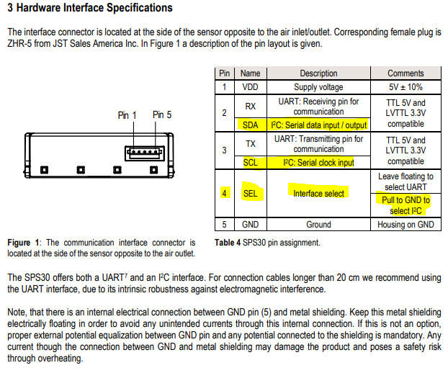
Fig no. 1: Pin Layout Table no. 1: SPS30 Pin Assignment

3.3 Data Flow
The system's data flow is structured to ensure real-time transmission and visualization:
SPS30 Sensor
c

c
ESP32

WI-FI
c

MQTT Broker
c

c
Vyom
Dashboard

Fig no. 2: Flow Diagram
Chapter 4
Implementation

4.1 Hardware Setup

Step 1: Connecting SPS30 to ESP32
- Connected the SPS30 and ESP32.
- Ensured proper wiring for the I2C protocol and tested with an I2C scanner to verify connections.
Step 2: Connecting DHT11 to ESP32
- Connected DHT11 sensor to ESP32 via a digital pin (GPIO18).
- Verified readings through Serial Monitor.
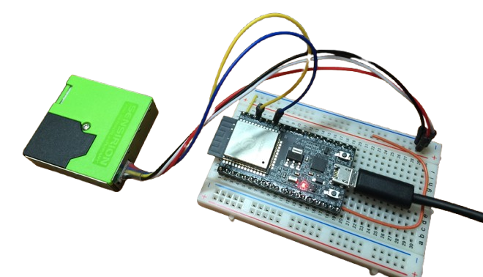
Fig no. 3: Connections

4.2 Software Development

Step 1: Setting Up ESP32
- Installed the following libraries for functionality:
  - Wire.h: To communicate with the SPS30 over I2C.
  - WiFi.h: To connect ESP32 to a Wi-Fi network.
  - PubSubClient.h: For MQTT communication.
  - ArduinoJson.h: To format data into JSON.
  - Sensirion_i2c: For SPS30 sensor readings.
  - sps30.h
  - DHT.h

Step 2: Initializing SPS30 Sensor
- Configured the SPS30 using the Sensirion library.
- Added a delay to allow the sensor to stabilize before taking readings.
- DHT11 initialized using DHT.h library.
- A 2-second interval is set between readings to allow stabilization.

4.3 MQTT Integration

Step 1: Configuring MQTT Broker
- Set up a HiveMQ broker for testing and created a topic (AMPL/sensor/data) for publishing data.

Step 2: Formatting Data in JSON
- Used the ArduinoJson library to create a structured JSON payload for MQTT transmission:
- {
- "PM1.0": 20.5,
- "PM2.5": 40.3,
- "PM4.0": 30.5,
- "PM10.0": 45.6,
- "VOC": 106,
- "NOx": 1,
- "Temperature": 27.3,
- "Humidity": 65.4
- }

Step 3: Sending Data
- Configured ESP32 to publish data every 10 seconds.
- Implemented reconnection logic to handle Wi-Fi and MQTT disconnections.
Challenges Faced:
- Payload Size:
  - Issue: Large payloads caused transmission delays.
  - Solution: Optimized JSON structure and reduced unnecessary fields.
Click here for code.

4.4 Dashboard Visualization

Step 1: Setting Up Vyom
- Created a device in Vyom and obtained an access token for authentication.
- Subscribed to the MQTT topic to receive data.

Step 2: Designing Widgets
- Designed real-time graphs for PM values, temperature, and VOC.
- Configured thresholds to highlight poor air quality conditions.

Chapter 5
Testing And Challenges Faced

5.1 Initial Testing
- Verified the I2C connection using an I2C scanner.
- Monitored sensor outputs on the Arduino IDE serial monitor.
- DHT11 values were verified for accuracy against a digital thermometer.

5.2 End-to-End Testing
- Published sensor data to the MQTT broker and confirmed receipt on Vyom.

5.3 Voltage Instability
- Problem: ESP32 restarts due to unstable power.
- Solution: Added capacitors and used a dedicated 5V adapter.

5.4 MQTT Public Broker Failure
- Problem: Data was not posted as broker fails.
- Solution: Created new Private MQTT Broker.

Chapter 6
Results

6.1 Sensor Readings
- The SPS30 sensor successfully provided accurate and stable readings for particulate matter and particle concentration in real-time indoor conditions.
- Sample readings during testing:
PM1.0: 48.27 µg/m³
PM2.5: 51.04 µg/m³
PM4.0: 51.04 µg/m³
PM10.0: 51.04 µg/m³
Typical Particle Size: 0.4 µm
NC0.5: 327.88 #/cm³
NC1.0: 383.41 #/cm³
NC2.5: 383.24 #/cm³
NC4.0: 385.36 #/cm³
NC10.0: 385.42 #/cm³
Temperature: 27.3°C
Humidity: 65.4%

Comparison Table: SPS30 Readings vs Recommended Air Quality Standards (Office Environment)
Sr. No | Parameters | Recommended Range (Office) | Office Value | Air Quality
1. | PM1.0 (µg/m³) | ≤30 | 48.27 | Poor
2. | PM2.5 (µg/m³) | ≤25 | 51.04 | Poor
3. | PM4.0 (µg/m³) | ≤35 | 51.04 | Poor
4. | PM10.0 (µg/m³) | ≤50 | 51.04 | Slightly Poor
5. | Typical Particle Size (µm) | 0.3 - 0.5 | 0.4 | Within Range
6. | NC0.5 - NC10.0 (#/cm³) | Not standardized for general office use | 327.88 – 385.42 | Reference Values
Table no. 02: Comparison of SPS30 sensor readings and recommended office air quality ranges.
The results show that particulate matter levels (PM1.0 to PM4.0) are significantly above the recommended threshold for indoor office environments, indicating poor air quality. PM10.0 is slightly above the safe limit. The particle size distribution is within a typical indoor range, and number concentration values (NCx) provide deeper insights for further particle density analysis. However, the main concern remains elevated PM levels, which can pose respiratory health risks over prolonged exposure.

6.2 Data Transmission
- Successfully transmitted JSON data to the MQTT broker with an average latency of 120ms.
- The data remained consistent during prolonged testing over 24 hours.

6.3 Dashboard Visualization
- The Vyom dashboard provided real-time graphs for each parameter with visual alerts for poor air quality.
- Feedback from end users indicated ease of use and reliability of the system.
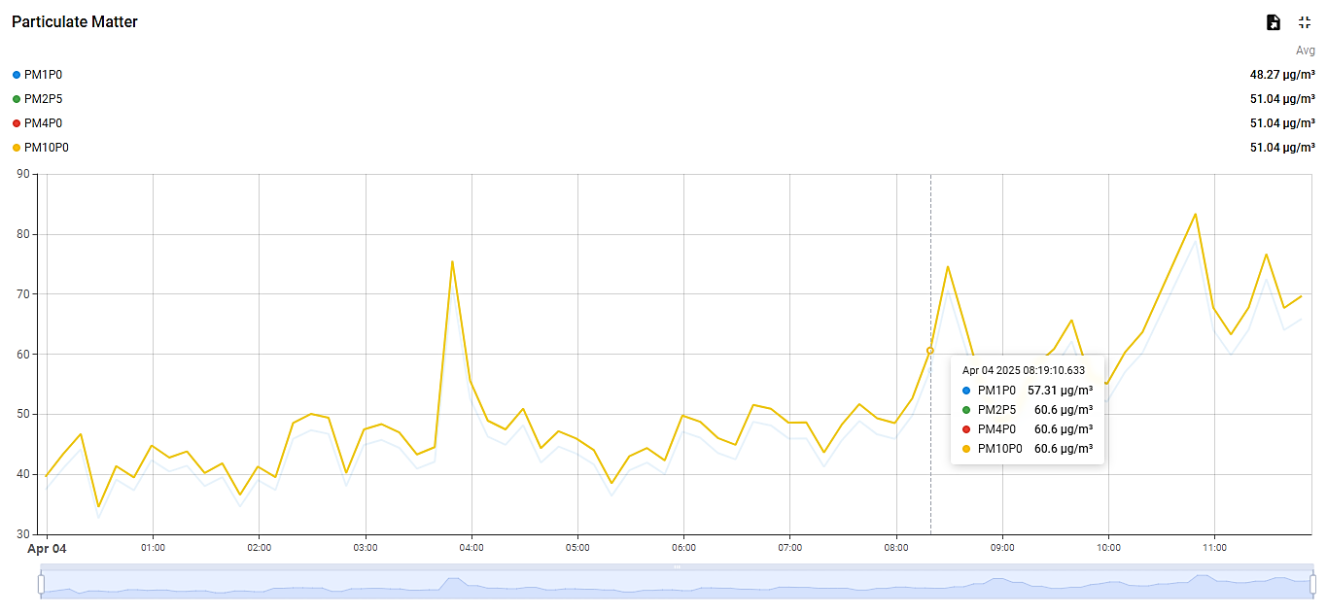
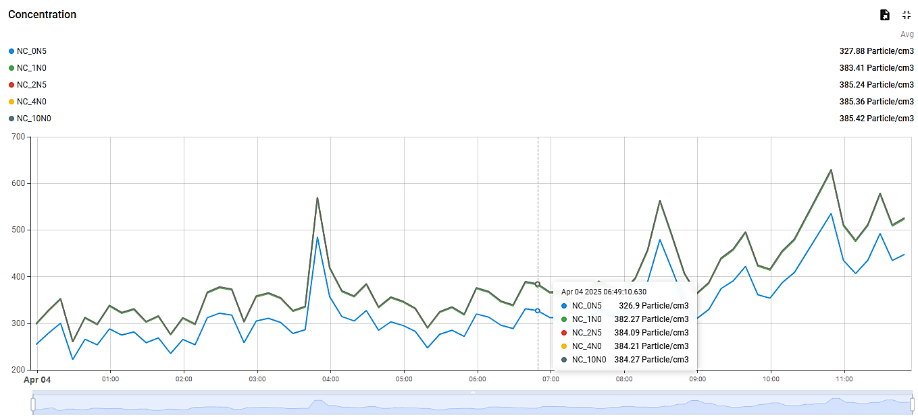
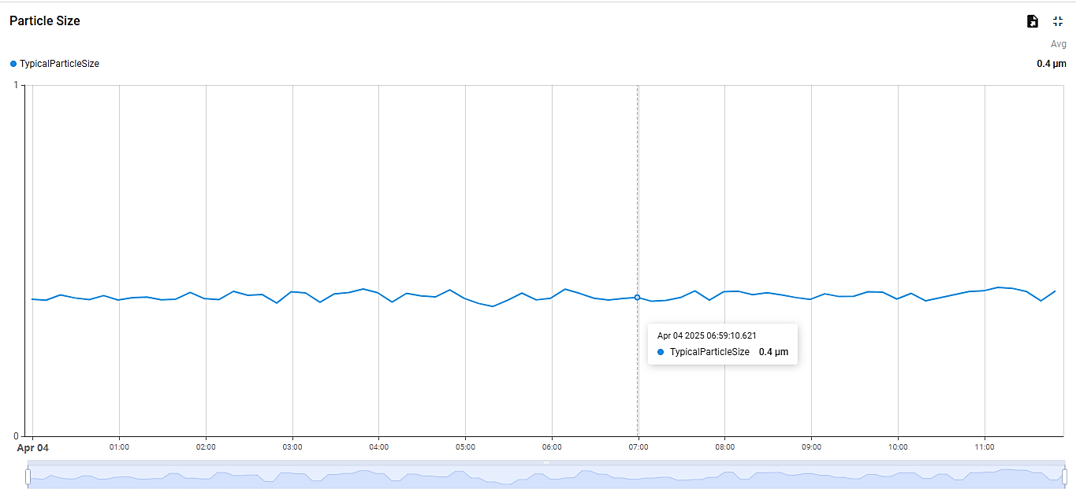
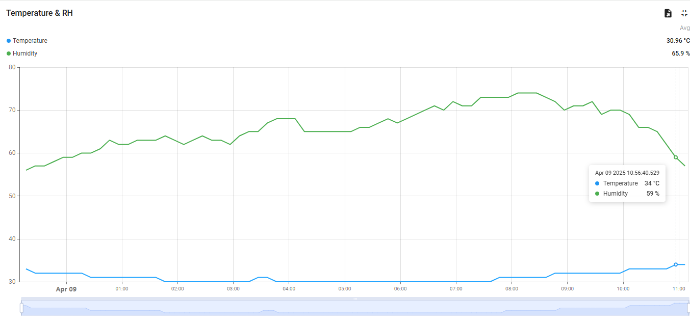

6.4 Challenges Overcome
- Voltage issues resolved with capacitors and a dedicated power source.
- Wi-Fi and MQTT disconnection issues were resolved with retry mechanisms.
- JSON formatting was optimized to ensure smooth data transmission.

Chapter 7
Conclusion and Future Scope

- Conclusion

This project successfully demonstrates a low-cost, scalable, and accurate IoT-based Air Quality Monitoring System using the SPS30 sensor and ESP32 microcontroller. It helps in real-time data acquisition and cloud-based visualization, which can be beneficial for environmental monitoring, research, and policy-making. Including the DHT11 sensor provided a complete picture of environmental quality by integrating temperature and humidity with air quality data.

Future Scope
- Deployment in urban smart city environments.
- Integration with weather stations for broader environmental context.
- Mobile app notifications for public alerts.
- Integration with AI/ML models for predictive analysis of air quality.

Chapter 8
References
- E. Hiller,
"ESP32 AQI Monitoring Using SPS30 and BME680 Sensors,"
GitHub Repository, 2023.
Available: https://github.com/erichiller/esp32_aqi_sps30_bme680_ssd1306

- B. Wirtz,
"Indoor Air Quality Monitor Using ESP32 and SPS30,"
GitHub Repository, 2022.
Available: https://github.com/bastienwirtz/air-quality-monitor

- S. M. Thakur, A. S. Kolhe, and R. S. Patil,
"IoT Based Air Quality Index Monitoring Using ESP32,"
International Research Journal of Engineering and Technology (IRJET), vol. 8, no. 4, pp. 3699-3703, 2021.
Available: https://www.irjet.net/archives/V8/i4/IRJET-V8I4994.pdf

- N. Shah and D. Shah,
"IoT Based Air Quality Index Monitoring System Using ESP32,"
International Research Journal of Wireless and Embedded Systems (IRJWES), 2022.
Available: https://www.irjweb.com/Iot%20based%20air%20quality%20index%20monitoring%20system%20using%20ESP32.pdf

